# Digital Geometry Processing (236329)

## HW 3

ID1: 204030720

ID2: 203300561

## Git

* All the code can be found in the following Git, matlab branch.
* The python version is under python branch.
* <https://github.com/ManorZ/cs236329.git>

## Q1 – Vector Field Visualization – plot_vector_field.m

The function uses our implementation for mesh visualization from HW#2 and adds on top a vector field quiver.  
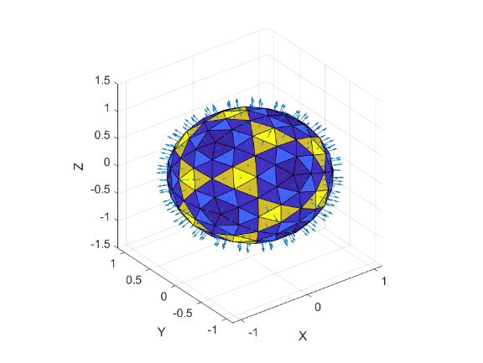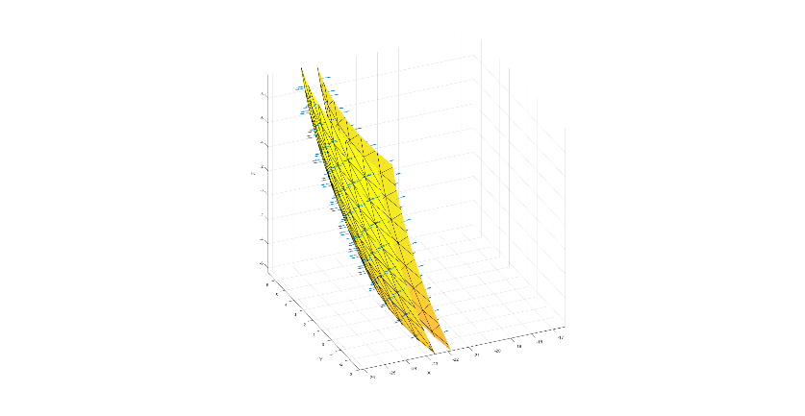

## Q2 – Discrete Differential Operators

### Q2.1 – Discrete Grad

The discrete gradient calculation is implemented here: *calc_grad.m*  
We experimented with several scalar functions on the vertices:

* Pulse:   
  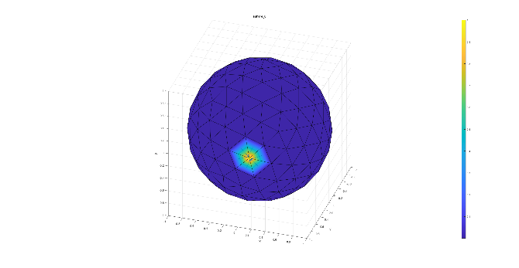Chart

  Description automatically generated with low confidence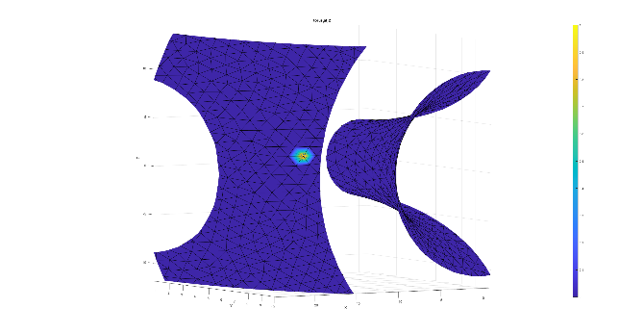A picture containing text

  Description automatically generatedA picture containing chart

  Description automatically generatedChart, radar chart

  Description automatically generated
* Barycentric Area:  
  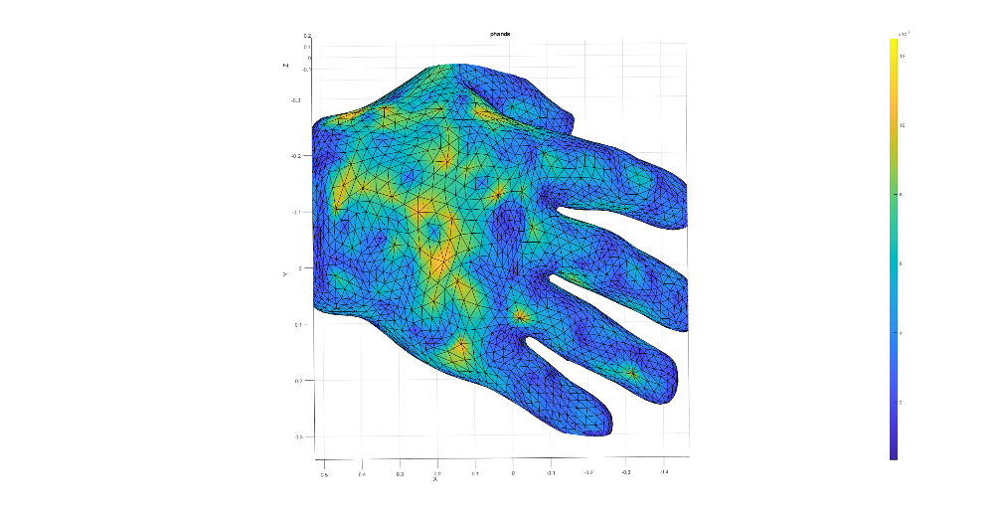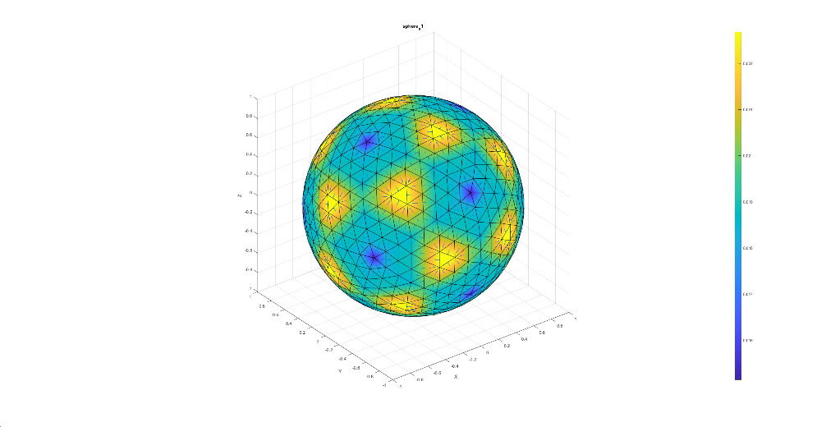
* X coords:   
  Chart

  Description automatically generatedChart

  Description automatically generated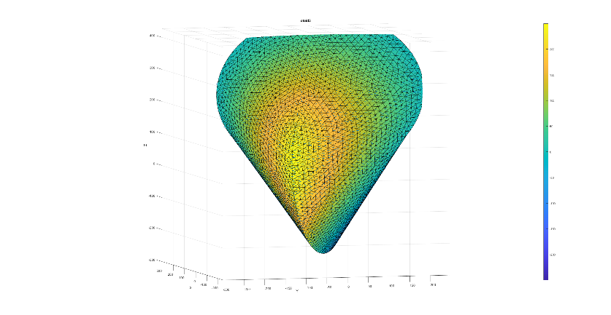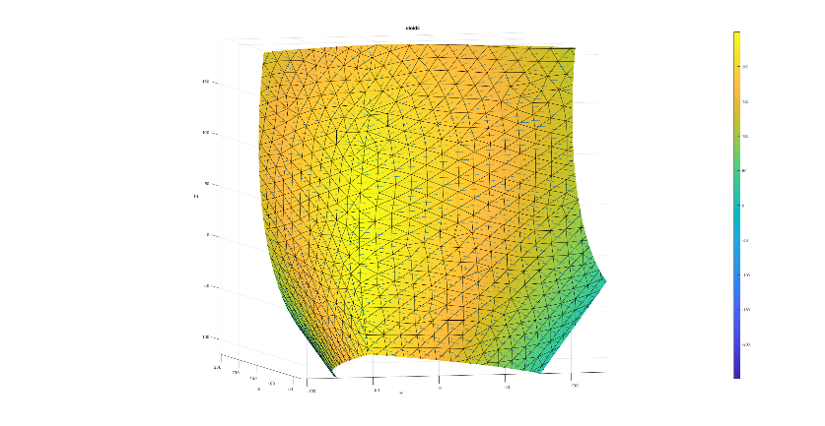

### Q2.2 – Discrete Div

The discrete divergence calculation is implemented here: *calc_div.m*  
We bring here a visualization for the vector function on faces: $f\left(x,y,z\right)=2x$ where $x,y,z$ are each face center.

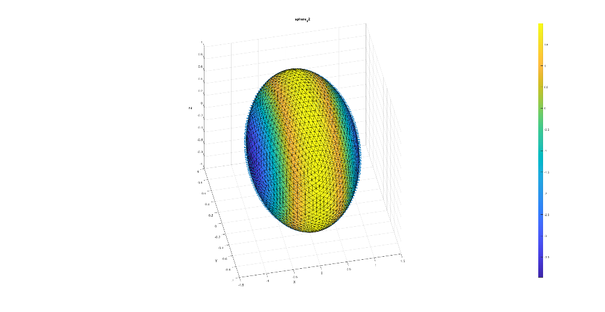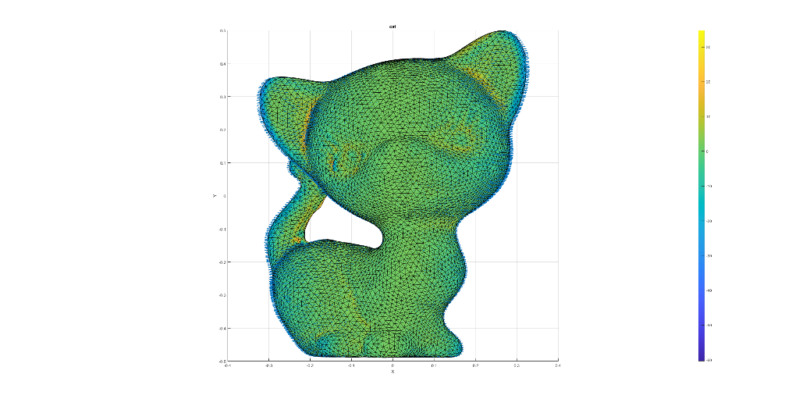

### Q2.3 – Discrete Laplacian

The discrete divergence calculation is implemented here: *calc_lap.m*  
We bring here a visualization for the gradient function on faces for a barycentric vertex area scalar function on vertices.

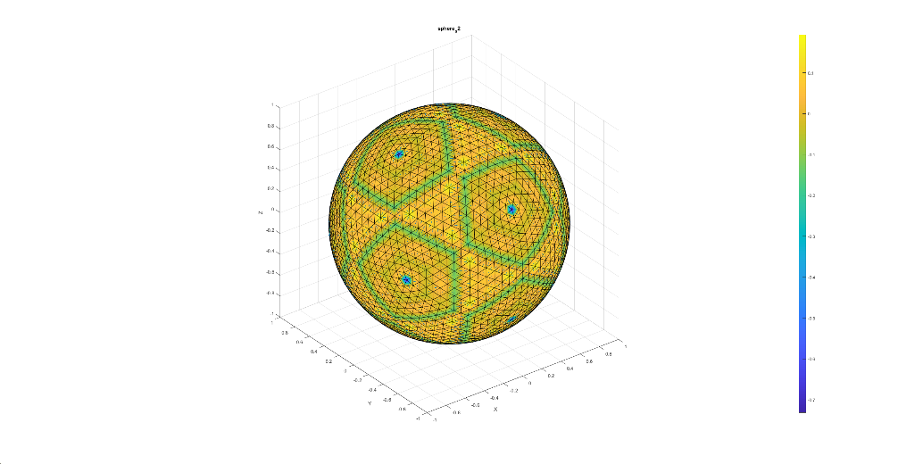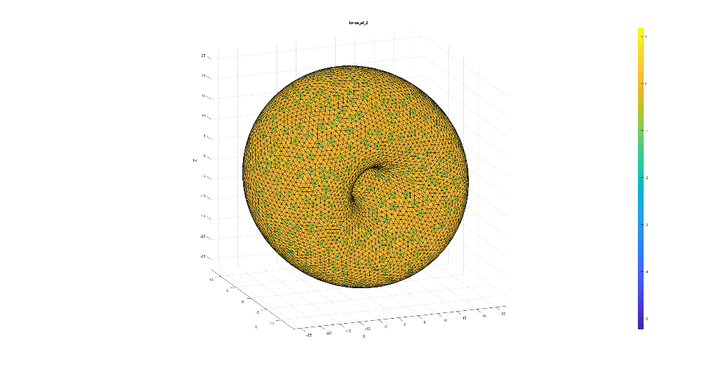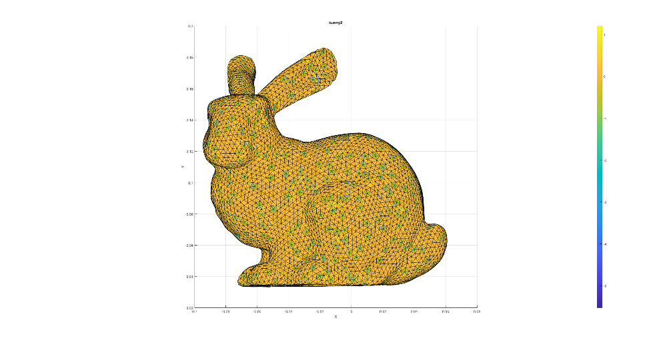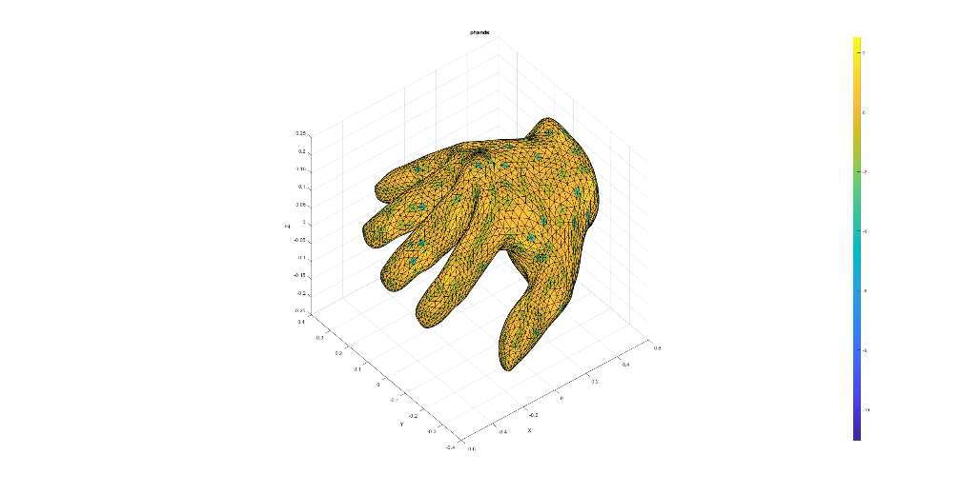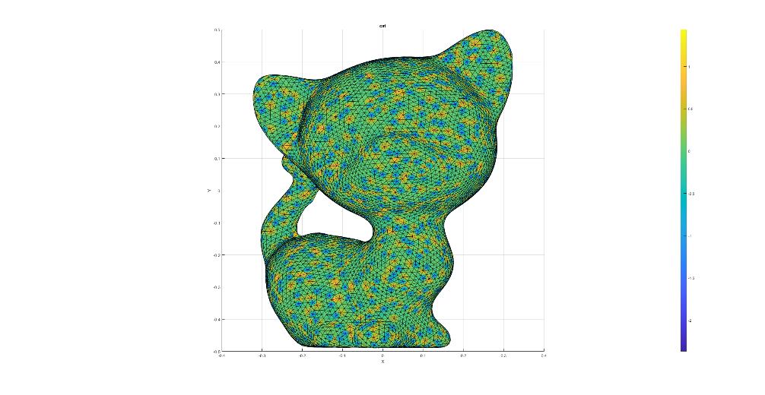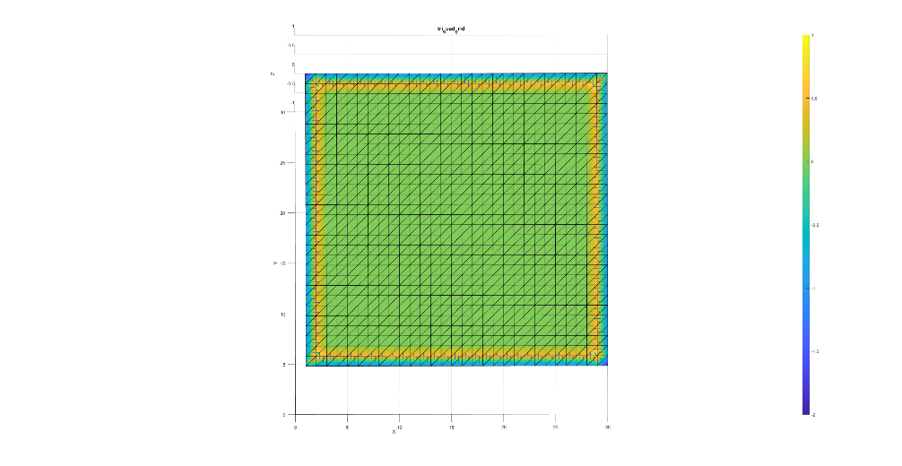

### Q2.4 – Laplace Beltrami

The Laplace Beltrami is calculated in the function: *calc_lap_beltrami.m*  
We run it on various mashes and measure the MSE error vs. the discrete Laplacian operator on the scalar function on vertices: $f\left(v_{i}\right)=2i$.  
  
We noticed that for some reason our algorithm does not work on 2d surfaces (disk, tri_quad_grid). We suspect it is because in the Laplacian Beltrami we assume no boundaries.  
In *calc_lap_beltrami.m* we assume regular edges only, a.k.a, two adjoint faces per edge.

reading hw2_data\bunny2.off ... calc lap ... calc lap beltrami ... done. ||Laplacian(F) - Laplacian-Beltrami(F)||^2 = 0.000039  
reading hw2_data\cat.off ... calc lap ... calc lap beltrami ... done. ||Laplacian(F) - Laplacian-Beltrami(F)||^2 = 0.000004  
reading hw2_data\oloid3.off ... calc lap ... calc lap beltrami ... done. ||Laplacian(F) - Laplacian-Beltrami(F)||^2 = 0.000000  
reading hw2_data\phands.off ... calc lap ... calc lap beltrami ... done. ||Laplacian(F) - Laplacian-Beltrami(F)||^2 = 0.000001  
reading hw2_data\sphere_s0.off ... calc lap ... calc lap beltrami ... done. ||Laplacian(F) - Laplacian-Beltrami(F)||^2 = 0.000000  
reading hw2_data\sphere_s1.off ... calc lap ... calc lap beltrami ... done. ||Laplacian(F) - Laplacian-Beltrami(F)||^2 = 0.000000  
reading hw2_data\sphere_s2.off ... calc lap ... calc lap beltrami ... done. ||Laplacian(F) - Laplacian-Beltrami(F)||^2 = 0.000000  
reading hw2_data\torus_fat_r2.off ... calc lap ... calc lap beltrami ... done. ||Laplacian(F) - Laplacian-Beltrami(F)||^2 = 0.000000  
reading hw2_data\disk.off ... calc lap ... calc lap beltrami ... done. ||Laplacian(F) - Laplacian-Beltrami(F)||^2 = 49661.878919  
reading hw2_data\tri_quad_grid.off ... calc lap ... calc lap beltrami ... done. ||Laplacian(F) - Laplacian-Beltrami(F)||^2 = 944.259498

The following plot assure our assumption regarding the boundaries. For each non-boundary vertex, we get 0 Laplacian, as expected. On the edges, we get something else, and it is different between the Laplace-Beltrami and the Discrete Laplacian.  
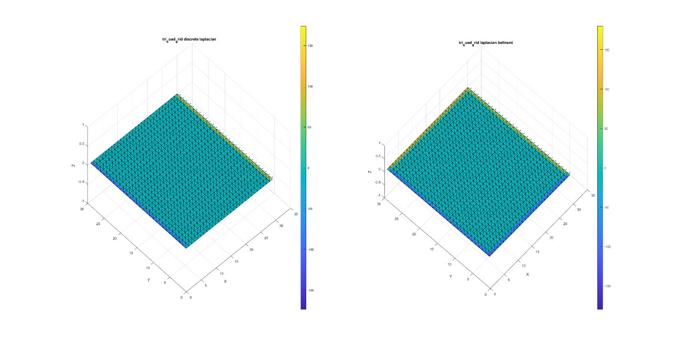

### Q2.5

Each couple of non-boundary vertices, forms two **rights triangles**, with $cot{45}^{o}=0$ in each side (see figure below). Therefore, the weights are zeroed, as so the Laplacian.

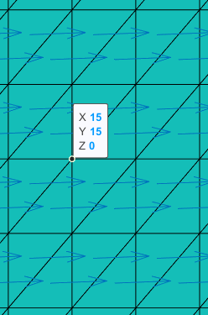



For boundary vertices, the Laplacian-Beltrami formula is not well defined, for example:  
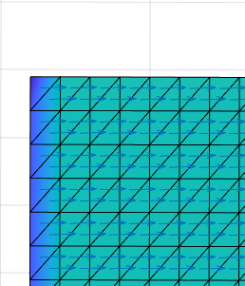

And therefore, we’ve got weird results in section Q2.4 for meshes with boundary.

## Q3 – Vertex Normal

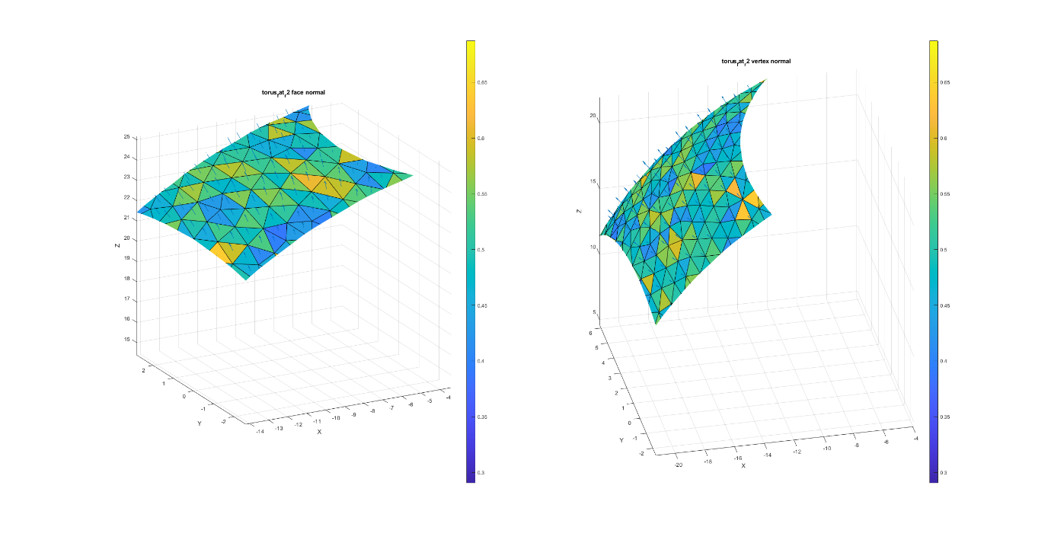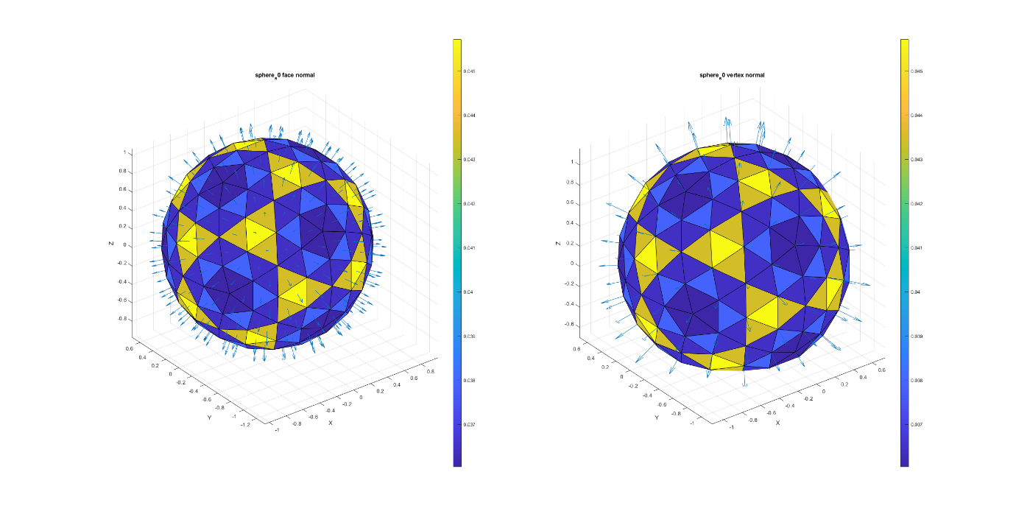

## Q4 – Curvature

### Q4.1 Gauss Curvature

The code is in *calc_gauss_curvature.m*.  
We tested our algorithm by calculating the curvature on a unit sphere, expecting 1 everywhere.  
And indeed, we get almost 1 everywhere:  
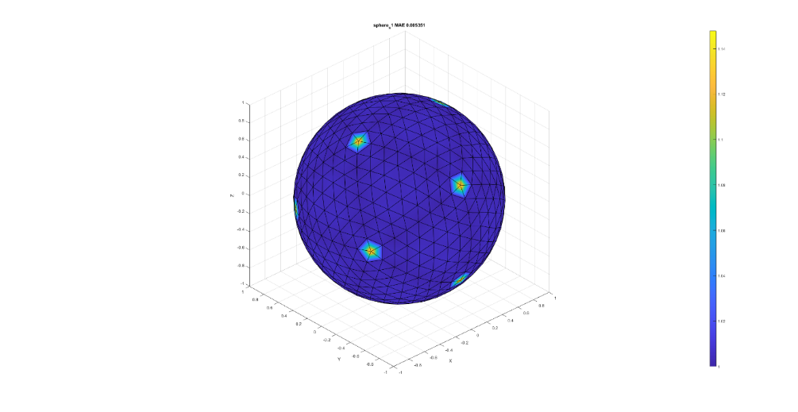

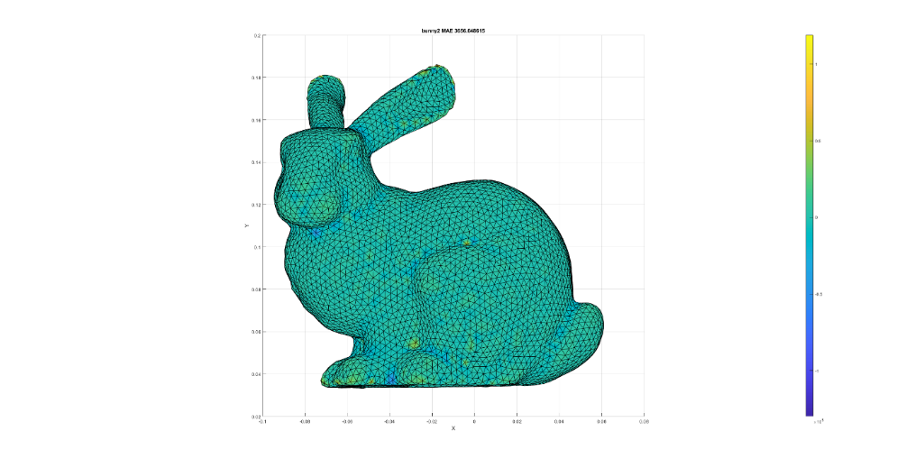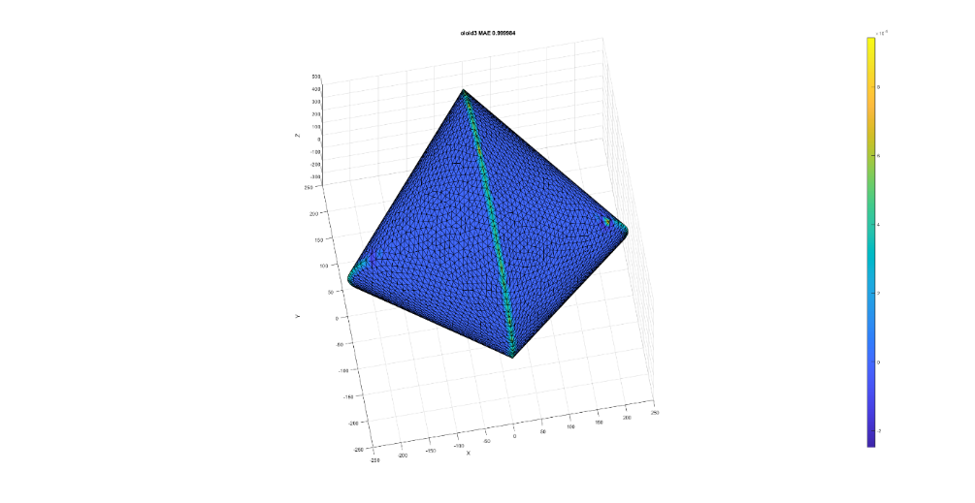

### Q4.2 Mean Curvature

The code is in *calc_mean_curvature.m*.  
We use the Laplacian-Beltrami, but instead of a scalar function we use the coordinates of each vertex. The idea is to measure ‘how fast $x,y,z$ change in each vertex from its neighbors’.  
We then calculate each vertex normal, and inner-producting it with the Laplacian.  
The results on a unit sphere are somewhat weird, not sure why.  
We expect it to be 1 everywhere on a unit sphere, like the Gauss Curvature.  
In a 2nd thought, it might be ok, up to a constant multiplicative scaling factor, since for other meshes, the cat for instance, we get higher values for ‘curvy’ areas, and lower values for ‘flat’ areas.  
